
CBSX - Knowledge Transition Document

Version 1.5
Last Updated Date: Aug 12, 2010

TABLE OF CONTENTS
1 Introduction 5
1.1 Purpose 5
1.2 Audience 5
1.3 Definitions and Acronyms 6
2 Application Overview 7
2.1 Business Overview 7
2.2 Key features of application 8
2.2.1 User Types 8
2.2.2 Trading Session 8
2.2.3 Trading Products 8
2.2.4 Types of Order and its Allocation 8
2.3 Stocks RegNMS 10
2.3.1 Introduction to RegNMS 10
2.4 Types of Stock Orders 13
2.4.1 Autolink Orders 13
2.4.2 Reserve Orders 14
2.4.3 Inbound Sweep Order 15
2.4.4 Cross Orders 16
2.4.5 Sweep & Cross order 18
2.4.6 Midpoint Cross Orders 19
2.4.7 Cross Order Enhancements 19
2.4.8 Odd/Mixed Lot Order 19
2.4.9 G Order 21
2.4.10 J Order & K Order 21
2.5 CBSX Billing Process 22
2.6 CBSX Billing Enhancement 23
2.7 NBBO Flash Enhancement 24
2.8 ‘DO NOT ROUTE’ contingency Enhancement 26
2.9 Multiple Router Enhancement 27
2.10 Drop Copies 28
2.11 Clearing 29
2.12 NBBO protection for ‘I’ order 30
2.13 Bid Peg and Offer Peg Contingencies 31
2.14 ISB Contingency 31
2.15 No Flash Contingency 31
2.16 Contingency Cross Enhancement 32
2.17 CBSX Market Order Handling 33
2.18 Tied Sweep and Cross 33
3 Application Architecture 34
3.1 CBOE Eco Trading System 34
3.2 Multi-Tier Architecture 35
3.2.1 CBOE direct logical view 36
3.2.2 Detailed level logical view 37
3.2.3 Logical view Brief Description 37
3.3 CBOE direct system process view 38
3.3.1 Process View Brief Description 38
3.4 High Level Data Flow 39
3.4.1 Quote Flow Scenario 39
4 Infrastructure & Environment 40
4.1 ATG Environment Detail 40
4.2 Access to CBOE Environment 40
4.3 Startup-Shutdown process information of CD in ATG environment 40
4.4 Extreme Ticker Plant (XTP) 40
4.4.1 Key Points 40
5 Testing Detail 42
5.1 Drop Copy User Setup 42
5.1.1 Manual Test Case Execution Procedure: 42
5.1.2 Execution using Option1: 42
5.1.3 Execution using Option 2: 42
5.1.4 Log Verification: 42
5.2 Testing Details of NBBO Flash Enhancements Price Improvement 43
5.2.1 Test Plan 43
5.2.2 Test Setup Instructions: 43
5.3 Testing Details of Help Desk Enhancement (HDE) 51
5.3.1 Test Plan 51
5.3.2 Test Setup Instructions: 51
5.3.3 Test Cases 51
5.3.4 Key Requirements of application 51
5.3.5 Testing Details of Help Desk Enhancement (HDE) 2 51
5.3.6 Test Plan 51
5.3.7 Test Setup Instructions: 51
5.3.8 Test Cases 52
5.3.9 Key Requirements of application 52
5.4 Testing Details of Help Desk Enhancement (HDE) 3 52
5.4.1 Test Plan 52
5.4.2 Test Setup Instructions: 52
5.4.3 Test Cases 52
5.4.4 Key Requirements of application 53

REVISION HISTORY
Version | Date | Revised By | Revision Details
1.0 | 4-Nov-2008 | Cognizant –  Manish Sharma | - Draft - Separate KT doc for CBSX  - Odd lots, NBBO Flash, Billing enhancement,G,J & K order
1.1 | 5-Nov-2008 | Cognizant –  Manish Sharma | - Multiple Router, ‘DO NOT ROUTE’ Contingency
1.2 | 01–Apr-2009 | Cognizant –  Manish Sharma | - Clearing, Drop Copies  - Modified document post review meetings with team on 17th Nov &1st Dec ’08 / 21st & 26th Mar ‘09
1.3 | 28-Oct-2009 | Cognizant –  Manish Sharma | - 8.1 & 8.2 release changes:-  ‘I’ order NBBO protection, Bid Peg & Offer Peg Contingency, ISB Contingency, No Flash functionality  - Separate and Independent KT doc for CBSX
1.4 | 9-February-2010 | Cognizant –  Bimal Beura | - CBSX Contingency Cross Enhancement

- Introduction
  - Purpose
The primary objective of this document is to provide:
- Overview of entire CBSX System
  - Audience
The intended audiences for this document are:
CBSX staff and Cognizant Quality Assurance Team
  - Definitions and Acronyms
Acronym | Description
ATG | Assurance Testing Group
BBO | Best Bid or Offer
CAS | Client Application Server
CMi | CBOE Market Interface
CFN | CBOE Financial Network
DTCC | Depository Trust & Clearing Corporation
DPM | Designated Primary Market Maker
FE | Front End
HDE | Help Desk Enhancement
ISO | Inbound Sweep Order
LMM | Lead Market Maker
LSP | Last Sale Price
MDC | Market Data Cluster
NBBO | National Best Bid Offer
Reg NMS | Regulation National Market System
OHS | Order Handling System
OMT | Order Maintenance Terminal
ORS | Order Routing System
PDPM | Preferred Designated Primary Market Maker
SIAC | Security Industry Automation Corporation
- Application Overview
  - Business Overview
CBSX has following main systems to process Stock:-
- Trading system
- Back office systems
The trading system ensures that the buyer and seller get a common platform to trade with each other through brokers. Brokers act as agents/intermediaries on behalf of the customer and pass the buy/sell orders to the exchange. These orders are routed to the exchange’s electronic trading system through OHS. In order to ensure that all buy and sell orders get a market to trade in, the exchange appoints market makers to give quotes (simultaneous buy-sell orders) on a group of products that the market maker is responsible for. These quotes generate liquidity in the market. Depending upon conditions, Price Time priority is used to allocate orders. Once the orders are matched, trade gets generated. The trade details are sent directly to DTCC for clearance. This process determines which firm shall pay and receive the money and delivers and receives securities on behalf of the customer. This is necessary since the executing broker and the clearing broker may be different entities.

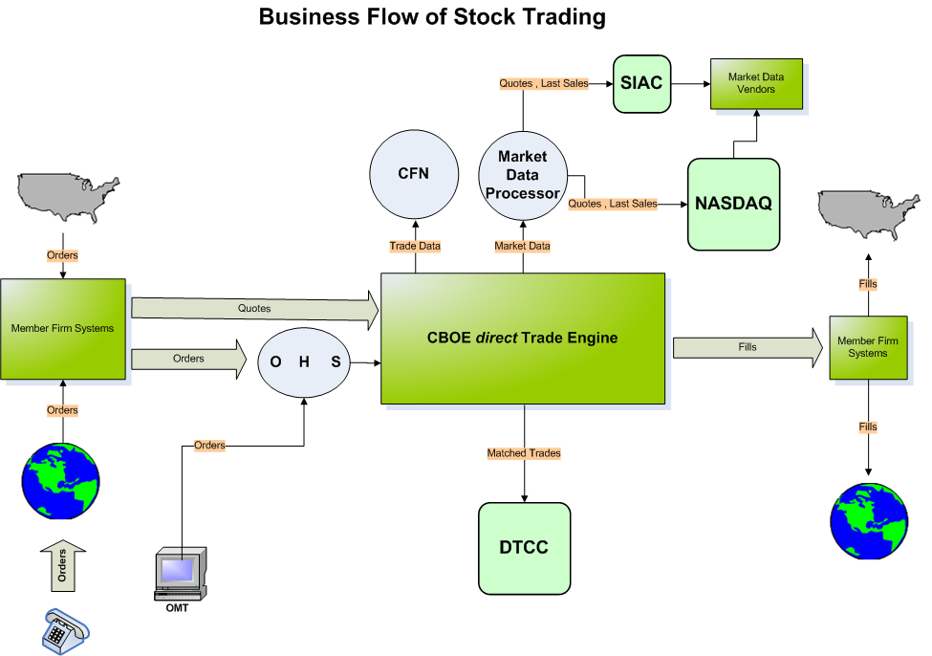

  - Key features of application
    - User Types
There are following types of users.
- Market makers
- Broker Dealer
- Class Display
- Customer Broker Dealer
- DPM
- Exchange Broker
- Expected Opening Price Role
- Firm
- Firm Display
- Help Desk
- Product Maintenance

    - Trading Session
Session represents set of trading rules for given set of products. Each session has a start time and end time associated with it. Following is the trading session:
W_STOCK
This represents stock’s trading session.
    - Trading Products
- Equity
- Index
    - Types of Order and its Allocation
      - Order Types
CBSX supports the following types of orders:
- Market orders
- Limit orders
- The following types of contingency orders
- AON – ALL or NONE
- AUCTION RESPONSE
- AUTOLINK CROSS / AUTOLINK MATCH
- DO NOT ROUTE
- CROSS
- CROSS WITHIN
- FOK – Fill or Kill
- IOC – Immediate or Cancel
- MIDPOINT CROSS
- NBBO_FLASH_RESPONSE
- NBBO_FLASH_THEN_CANCEL
- RESERVE
- STOCK ODD LOT NBBO ONLY
- SWEEP
- TIED CROSS
- TIED CROSS WITHIN
- Bid & Offer Peg
- ISB
      - Allocation Schemes

Price-Time Priority
Resting orders in the Stock book would be prioritized according to price and time, if two or more orders were at the best price, priority among these orders would be afforded in the sequence in which the Stock System received them. Currently in CBSX, Price – Time priority is set for executing orders.

Pro Rata Priority
Resting orders in the Stock book would be prioritized according to price. If there were two or more orders at the best price, public customer orders would be executed first and any remaining size would be allocated to the non-public customers at the best price proportionally according to order size.

*Public Customer Priority (Configurable but, currently out of CBSX)
If this were the only priority overlay in effect, the highest bid and lowest offer would have priority, except that a public customer order would have priority over a non-public customer order at the same price. If other priority overlays were also in effect, priority would be established in the sequence designated by the appropriate Stock Trading Committee. In either case, if there were two or more public customer orders at the same price, priority would be afforded to these orders in the sequence in which they were received by the Stock System, even if the pro rata allocation method were the designated allocation method.

*Market Turner (Configurable but, currently out of CBSX)
If market turner priority were the only priority overlay in effect, the market turner would have priority at the highest bid or lowest offer that it had established. If other priority overlays were also in effect, priority would be established in the sequence designated by the appropriate Stock Trading Committee.

Trade Participation Right
Stock DPMs and Stock LMMs may be granted a trade participation right to trade against up to 40% of an incoming order at a given price, even though the order and/or quote of the Stock DPM/LMM did not have the highest time priority at that price.

Key Features of CBSX
Quoting: Members that are appointed to a class submit two-sided quotes using proprietary systems or third party vendors.
Automatic Execution: Marketable orders from customers, firms, broker-dealers, and market makers automatically execute if CBSX is on the NBBO. When CBSX is not the NBBO, orders are handled using Autolink.
Bookable Orders: The CBSX book accepts orders from all types of market participants. The book also handles a number of contingency orders, including: All-or-None, Immediate-or-Cancel, Fill-or-Kill and Stop and Stop Limits.
Auctions / NBBO Flash: Stock orders are NBBO protected as per RegNMS. NBBO Flash / Auctions are started at NBBO price if CBSX is not the NBBO. Incoming orders marketable at NBBO price gets traded with the flashed order. Otherwise the orders are shipped to the away exchange. The Odd lot orders are also NBBO protected but, these are not shipped to the away exchange.

  - Stocks RegNMS
    - Introduction to RegNMS
The Commission has adopted Regulation NMS, a series of initiatives designed to modernize and strengthen the national market system (“NMS”) for equity securities. These initiatives include:
- A new Order Protection Rule, which reinforces the fundamental principle of obtaining the best price for investors when such price is represented by automated quotations that are immediately accessible;
- A new Access Rule, which promotes fair and non-discriminatory access to quotations, displayed by NMS trading centres through a private linkage approach;
- A new Sub-Penny Rule, which establishes a uniform quoting increment of no less than one penny for quotations in NMS stocks equal to or greater than $1.00 per share to promote greater price transparency and consistency;
- Amendments to the Market Data Rules and joint industry plans that allocate plan revenues to self-regulatory organizations (“SROs”) for their contributions to public price discovery and promote wider and more efficient distribution of market data; and
- A reorganization of existing Exchange Act rules governing the NMS to promote greater clarity and understanding of the rules.
      - States of Operation
The Stock System rules define five states of operation: pre-opening, opening, trading, trading halt, and closed.
The product state is changed everyday from ‘Pre-Open’ to ‘Opening Rotation’ at 8:15 AM CST. Depending on the available quote and order matching rule the products change its state from ‘Opening Rotation’ to ‘Open’.

Table below mentions details about order types accepted at various product states for Stock:
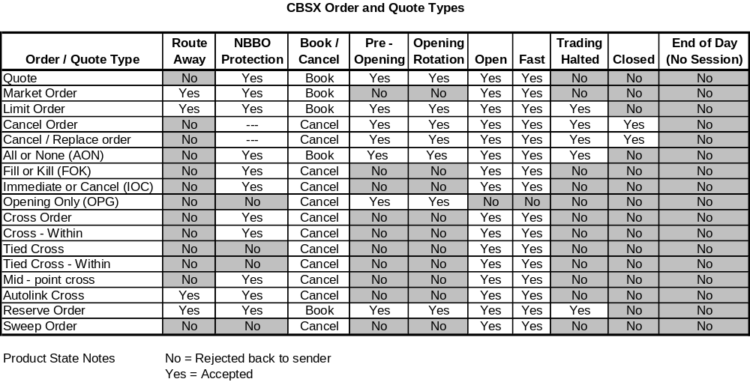
Table below mentions details about features for various origin types:
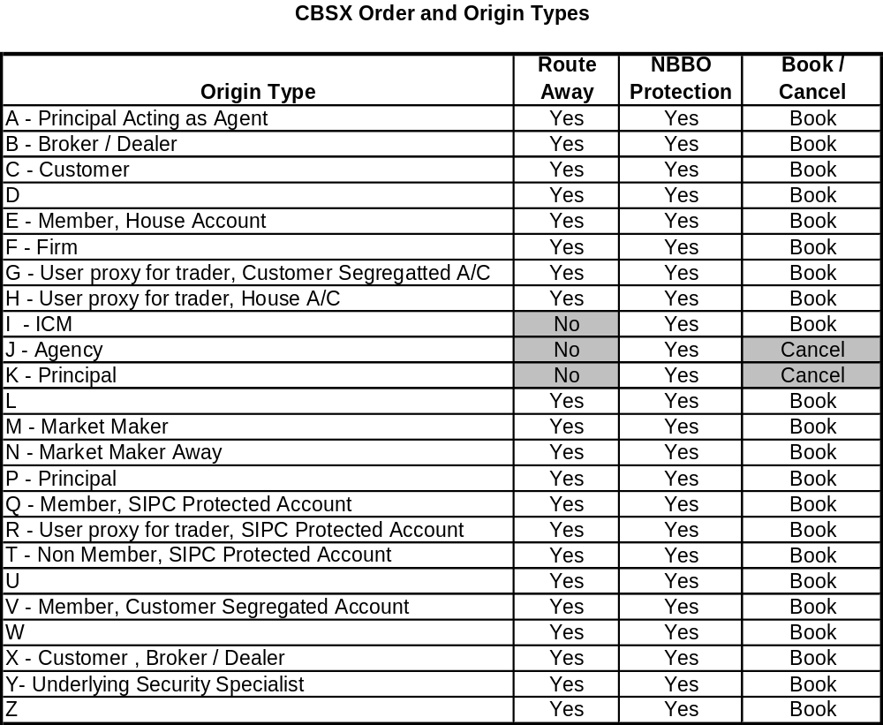
Table below mentions details about Origin types accepted for various contingency:
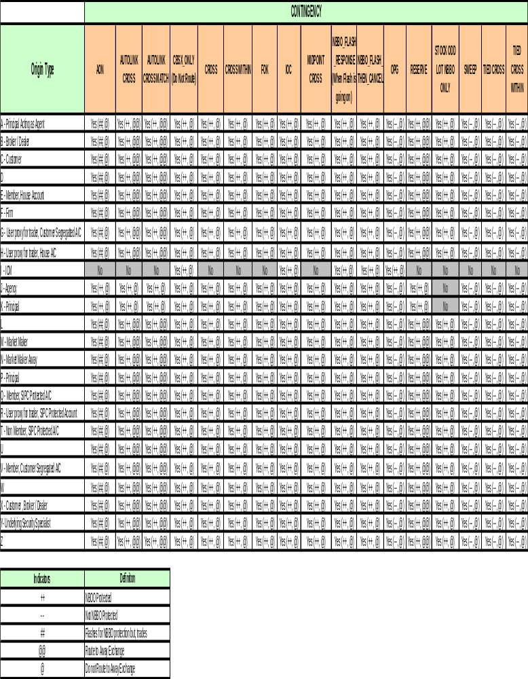

  - Types of Stock Orders
    - Autolink Orders
As per REG NMS, all orders are NBBO protected. e.g. when CBSX receives an order which is marketable order at a time when CBSX is not at NBBO, then most of the orders are sent (autolinked) to best away exchanges except orders like I, J & K.

In case CBSX is not the NBBO, it links away the Round lot order to away exchanges. For Mixed lot / Odd lot orders, it links away the round lot portion and starts odd lot auction for Odd lot portion / Odd lot orders when CBSX is not the NBBO.

In CBSX, whenever NBBO protected odd lot orders are received, these odd lot orders are flashed for market makers at NBBO for a specified period of time. If any orders are received opposite to Flash orders at or better than NBBO, then it will be traded at CBSX.

Linkage orders are created in Equity trade server (ETS) and then sent to OHS server. When such orders have to be routed to other exchanges, OHS send these linkage orders to linkage server and linkage server routes these orders to outbound routers REDI, BRASS & OES for routing orders to away exchanges. Outbound router sends such orders to away exchange. When it receives fill/reject responses from away exchanges, the flow is just in reverse direction.

Below will be technical flow for autolink orders (after 7.2 release):

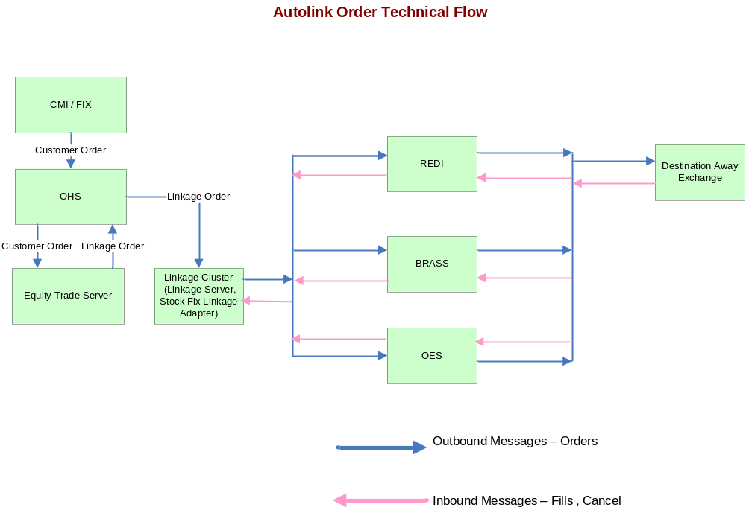

Below is the Business flow:

Autolink Order Business Flow

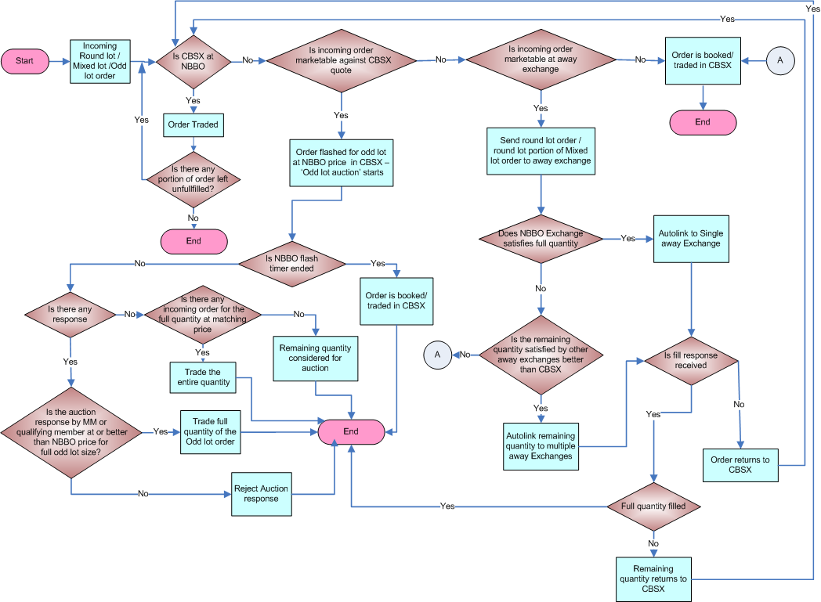

Note: The remaining quantity / fill response from Away Exchange returns to CBSX twice, after that the order is booked / traded in CBSX.

    - Reserve Orders
Reserve order is a limit order in which the order originator designates a portion of the order for display and dissemination (called the “display quantity”) and designates a portion of the order in “reserve.” The reserve quantity is not displayed but is available for execution against incoming orders. The ‘display quantity’ is refreshed when it goes below certain threshold value, subject to the condition if some quantities remain in the Reserve Order after execution. The remaining quantity balance would remain in reserve.

    - Inbound Sweep Order
A limit order that would sweep other side of the book even when away market is at a better quotation. This order will not have NBBO protection.
Inbound Sweep Order Business Flow
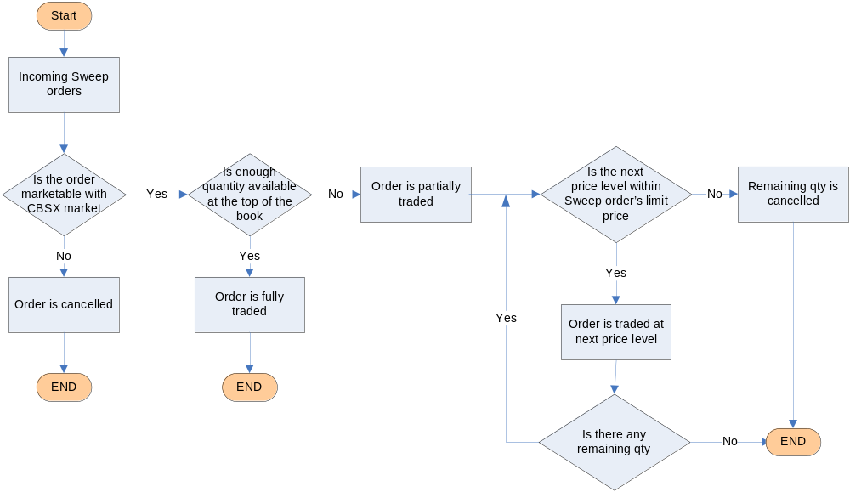

    - Cross Orders
Cross orders - An order that could be executed against another Cross order for the same quantity and price. There are various kinds of Cross orders namely Cross, Cross within, Tied Cross, Tied Cross within, Autolink Cross, Mid Point Cross, Bid Peg, Offer Peg .
Cross orders are entered in two ways:-
- Together – Both buy and Sell side cross order are entered together. Depending on quantity and price match, the orders are executed.
- One after Another - The buy and Sell cross order are entered one after another. In such case, the cross order waits for matching opposite side cross order. Depending on price and quantity match the order is executed.
A ‘Buy’ Cross order waits for opposite side ‘Sell’ cross order with same price and quantity and vice versa. The trade happens as soon as the both side of the cross order with same quantity and price is available in the system.
NOTE: The trade for cross orders may also happen with other resting orders subject to the condition if its price is better than the available opposite side cross order.
Cross and Cross within orders
Cross - When CBOE is at NBBO, then Cross order will trade at or better than CBOE market.
Cross - When CBOE is not at NBBO, then Cross order will trade at or better than NBBO.
Cross within - When CBOE is at NBBO, then Cross order will trade only within CBOE market.
Cross within - When CBOE is not at NBBO, then Cross order will trade at or better than NBBO.

Business Flow
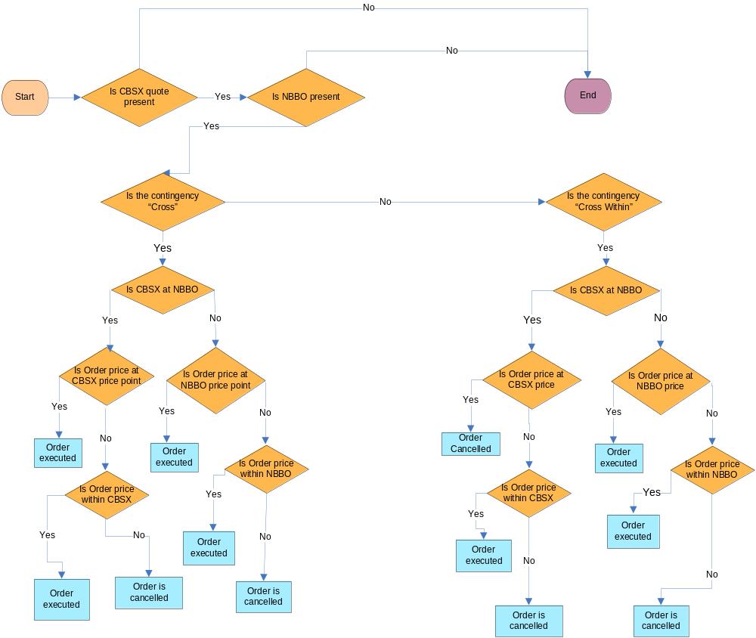

Tied Cross and Tied Cross within orders
Tied Cross - When CBOE is at NBBO, then Cross order will trade at or better than CBOE market.
Tied Cross - When CBOE is not at NBBO, then Cross order will trade through but at or better than CBOE market.
Tied Cross within - When CBOE is at NBBO, then Cross order will trade only within CBOE market.
Tied Cross within - When CBOE is not at NBBO, then Cross order will trade through but trade within CBOE market.

Business Flow
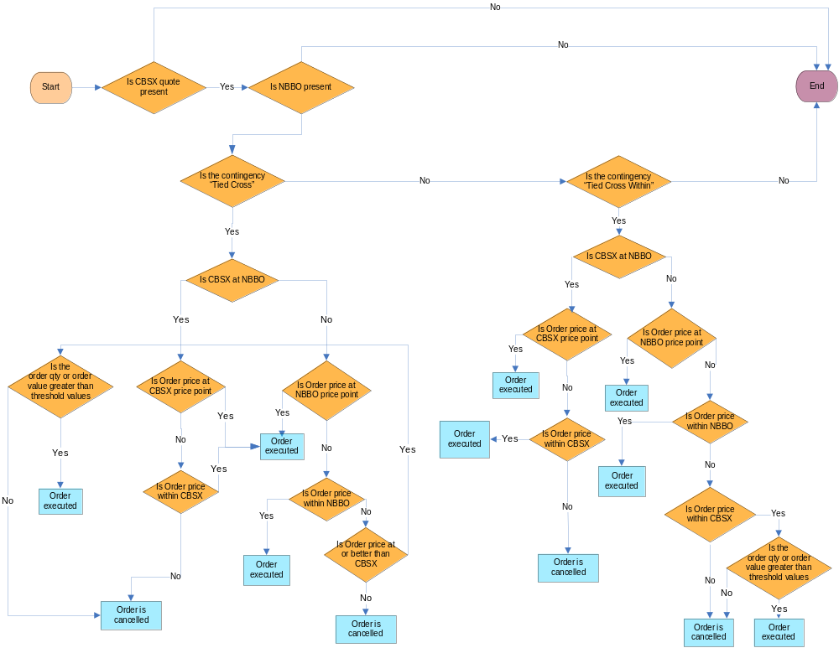

    - Sweep & Cross order
A Cross order which will have 2 parts, Autolink Cross and Autolink Cross Match. Autolink Cross orders will be autolinked to away exchange if CBSX is not NBBO. Any unfulfilled portion will match with Autolink Cross Match. All unfulfilled portion of Autolink Cross Match will get cancelled. If CBSX is at NBBO, Autolink Cross potion will match with the portion of Autolink Cross Match if the order price is at or within CBSX price point. Otherwise, these orders will get cancelled.

Business Flow
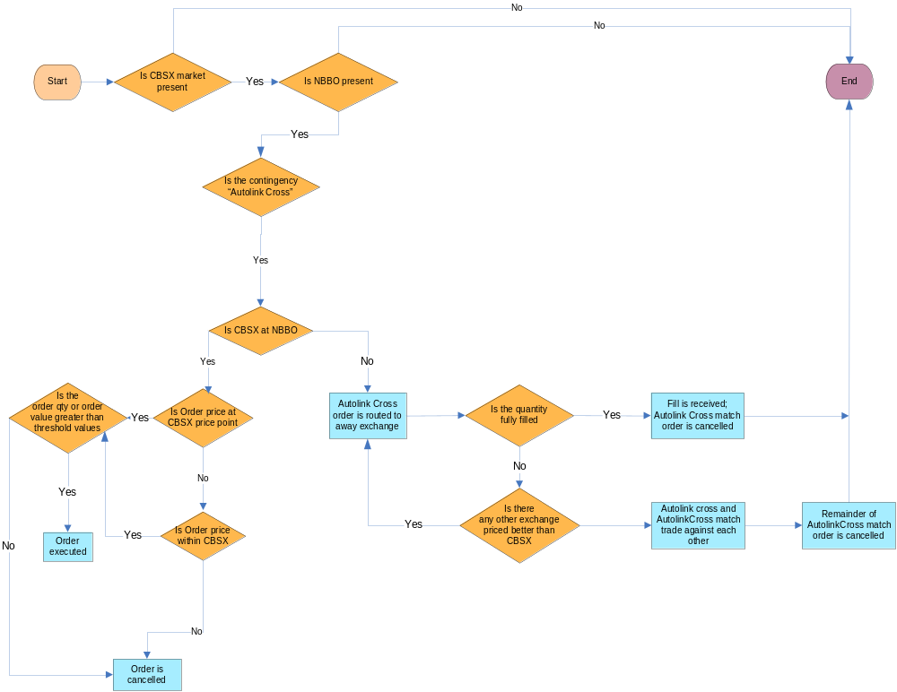

    - Midpoint Cross Orders
Midpoint Cross order - A market order submitted to trade at the midpoint of the NBBO. It must always be submitted with a contra order for the same size. But paired midpoint cross order will be submitted for one side, other side would be entered by a different user. It will always trade at mid point of NBBO.
    - Cross Order Enhancements
This enhancement will ensure that ‘P’ and ‘P/A’ orders are treated exactly like normal orders except ‘I’. These orders will now be able to link away to away exchanges. P and P/A orders will allow odd-lot and mixed lot quantity. Crosses will now, by default be accepted when they are “tied” with the NBBO i.e. trade price matches the bid or offer. New Cross types outside the NBBO can be accepted now provided they are better than CBOE market.
    - Odd/Mixed Lot Order
With recent enhancement, the NBBO protection is provided to odd lots orders. When CBSX receives an Odd lot order, it first looks for a matching order at NBBO in the book. If a matching order exists, the system trade. If not, CBSX immediately starts ‘Odd Lot Auction’ indicating the side and size of the odd lot as well as the NBBO price on that side of the market to all the interested parties. It holds the odd lot order while waiting for the responses. The NBBO flash timer for ‘X’ millisecond is started. The auction response must be for the full size of the odd lot. The first participant to respond at NBBO or better trades against the resting odd lot at the price of response. Any price worse than NBBO is rejected. If there is no auction response at NBBO or better before NBBO flash timer ends, the odd lot trade against any CBSX market makers with interest at the CBSX BBO. If there are no market makers at the CBSX BBO, the odd lot order is booked. Once the odd lot order is booked, CBSX market makers and interested parties can send an odd lot order to trade against the booked order. Additionally, if a market maker displays a regular quote at the CBSX BBO, it trades against the booked odd lot order. A new contingency type ‘STOCK_ODD_LOT__NBBO_ONLY’ is added which allows the odd lot sender to indicate that the order should be auctioned and then cancelled if it cannot trade at the NBBO. An odd- or mixed-lot order with an IOC contingency trades against resting market makers at the NBBO. If it cannot trade at the NBBO, it gets cancelled. The odd lot portion trades at the CBSX market if it includes market maker interest; otherwise the odd lot portion is cancelled. Odd lots are not being routed to away exchanges. The odd lot portion of a mixed lot is treated as an odd lot.
ODD Lot – Business Flow
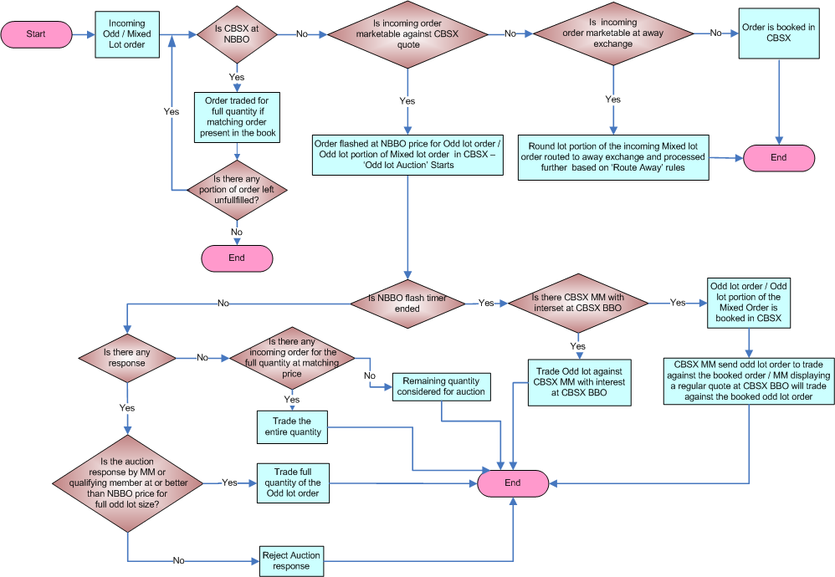
Some of the other trading rules for Odd/mixed lot orders are as follows:
- An odd lot or mixed lot order with IOC contingency will trade against resting market maker at the NBBO. If it cannot trade at NBBO, it will be cancelled.
- A mixed lot order with AON contingency is rejected.
- Odd lot orders do not get routed to away exchanges at the end of the odd lot auction.
- Even if an odd lot order is marketable against a customer round lot order, it is not traded against it.
- Odd lot order can be traded against a round lot quote or a round lot quote like order
- A quote with odd lot quantity will not be accepted. If a quote with round lot quantity trades with an incoming odd lot order leaving behind an odd lot quantity in the quote, then the quote should be cancelled immediately. But if the quote is left with mixed lot quantity, then this rule is not applicable
- An incoming quote like order with odd lot quantity is cancelled
Mixed Lot – An order with quantity comprised of a round lot order and odd lot order. These orders will also have NBBO protection.
    - G Order
Orders with ‘G’ origin type in W_STOCK are configured as regular customer order; however, it will be cancelled under the following conditions:
- User Logout
- Product being closed/halted/suspended
- Failover
    - J Order & K Order
The CBSX treats J & K types of orders in slightly different manner than other types of orders. When CBSX receives a J or K origin order, it checks if CBOE is at NBBO. If yes, then the order is executed. If no, then the order is cancelled.

J and K order type can be also defined as below:

J = A + ‘Do Not Route Contingency’
K = P + ‘Do Not Route Contingency’

Following is the business flow diagram of J & K order:

J & K Order Business Flow

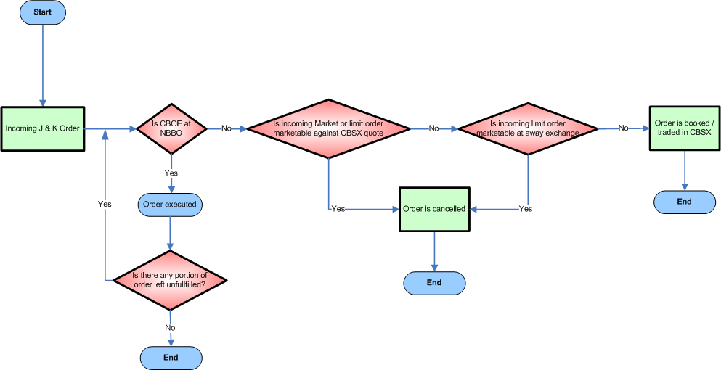

Following contingencies are allowed for J & K order:

AON, DO NOT ROUTE, FOK, NBBO_FLASH_RESPONSE, NBBO_FLASH_THEN_CANCEL, RESERVE

  - CBSX Billing Process
The CBSX billing is calculated based on contingency type, trade type and ‘Buy / Sell’ bill type code. Following are the brief detail of the billing process:
- As soon as possible after month-end (generally 3 or 4 business days), the monthly billing totals per the Firm58 website are reviewed for reasonability. This is done by both verifying the volume amounts against other internal sources (generally Trade Ops. numbers), as well as verifying that the average transaction fee rate used for each trade category for each firm on the Firm58 site agrees to the current fee schedule (compared with the “Firm Summary” report on the Firm58 site).
- After reasonableness testing, the bills for each clearing firm for the current month to be billed are selected for processing through the Firm58 site. A file is then generated that goes to the CBOE servers for further processing, as well as emailed to myself. A call is then placed to Computer Operations to finalize the process of generating the file and sending via FTP to DTCC.
- A spreadsheet is then populated detailing the firms and the amount to be billed/credited for each clearing firm. This file is emailed to DTCC.
- Depending upon whether CBSX owes or is owed money, a wire is either sent to DTCC, or a wire is sent to CBSX for the net amount of all the firms activity.

  - CBSX Billing Enhancement
This enhancement will provide billing information directly from the trade engine for both back office as well as real time fill reports. The data required to generate billing are taken from CTMR. This method enables CBSX to offer more competitive billing structure.
It will help CBOE to bill their clients effectively by tagging every trade with a billing type viz. Maker/Taker/Opening/Cross/Flash/Flash Response/Linked Away/linkage response. Orders that provide liquidity to the market will be marked as “Maker” i.e. resting orders. And orders that take away the liquidity are marked as “Taker” i.e. incoming orders those trade with the resting orders. Orders which are part of opening trade will be marked as “Opening”. Orders that have been crossed will be marked as “Cross”. Orders that have been flashed / auctioned will be marked as “Flash”. Any response to this order which trades with flash will be marked as “Flash Response”. If it is auto linked and filled by other exchange then it will be marked as “Linked Away”. These billing types will be marked only after the trade.
The round lot indication will be also added with the trade. This will show the portion of the order that was the round lot amount of the trade.
The fill report will be modified to include above billing information. The fill report through FIX and CMi will be also modified. Drop copies will also include this information. Billing data will be added to the fill reports in such a way that users are not required to accept the data.
Below is the Billing Enhancement Process Flow diagram:
Billing Enhancement Process Flow:
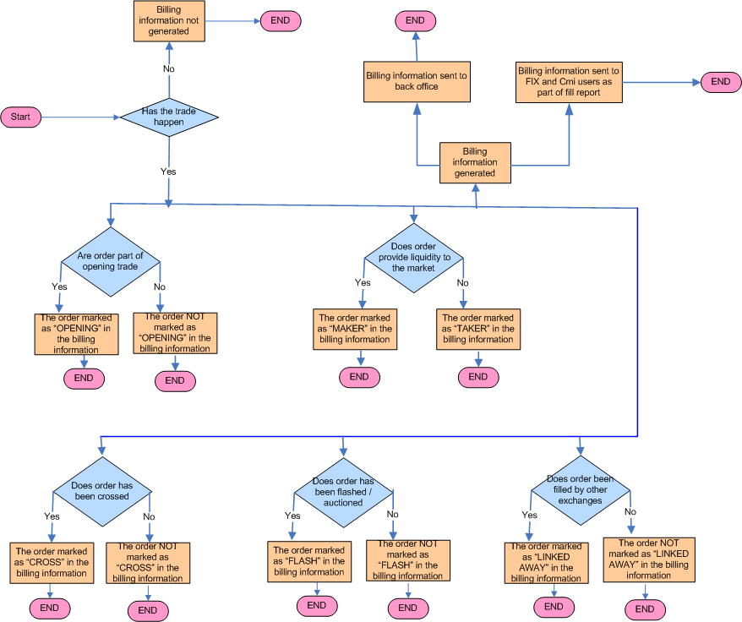

  - NBBO Flash Enhancement
A new linkage Preference table will enable the orders to choose the away exchange where the order will be shipped if more than one exchange matches the NBBO. Now Stock flash message enables the flash for Odd lot at NBBO price when CBOE is not NBBO.
NBBO Flash enhancement for CBSX: -
- CBOE direct will accept responses to the NBBO Flashed odd lot order with FLASH_RESPONSE contingency.
- The orders with FLASH_RESPONSE contingency will behave like orders with IOC contingency (Immediate or Cancel).
- When a marketable odd lot / mixed lot order is received that cannot trade against the CBSX quote due to NBBO restrictions, the odd lot / odd lot portion of mixed lot order will be flashed at the NBBO.
- A flash auction message will be sent as it is today.
- The flash will continue for ‘X’ milliseconds.
- Users responding to the flash will respond with a new NBBO Flash response contingency type.
- Flash responses can be sent in prices with up to 4 decimal places.
- The flashed order will trade against the flash response at the price of the flash response as long as it is at the NBBO or better.
- Flashed orders will trade immediately against the first flash response received.
- If the size of the first flash response is smaller than the size of the flashed order, the flash will continue until the order is filled in full or the flash timer ends.
- If there is a resting order at the same price and is the same side as the flash response, the trade price will be one full penny better than the resting order.

NBBO Flash – Business Process Flow:
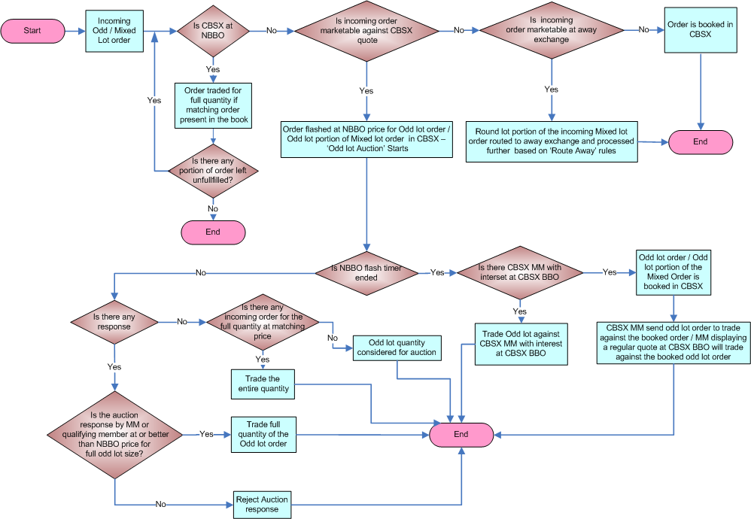

NBBO Flash Response:-
- Flash Responses can trade only with a Flashed Order
  - Incoming Flash Response trades a TICK BETTER than the NBBO on the SAME side if CBOE is the NBBO with resting orders on the Flash’s side
  - Incoming Flash Response will immediately be CANCELLED when there is no ongoing NBBO Flash
- Flash Responses will be priced up to 4 decimal places facilitating sub-penny price improvement – Note: Its pending for SEC approval.
- Flash Responses cannot be priced at MKT
- Flash Responses can be in odd lots only
- Irrespective of the origin type, all Flash Responses are treated the same and are handled like a standard Flash Response

NBBO Flash Then Cancel:-
When CBSX receives order with contingency type ‘NBBO FLASH THEN CANCEL’, it will check if CBSX is at NBBO. If yes, then the order is executed. If no, then the order will be flashed at NBBO price in CBSX. The order will be cancelled as soon as the NBBO flash time is ended.

‘NBBO Flash then Cancel’ Order Business Flow

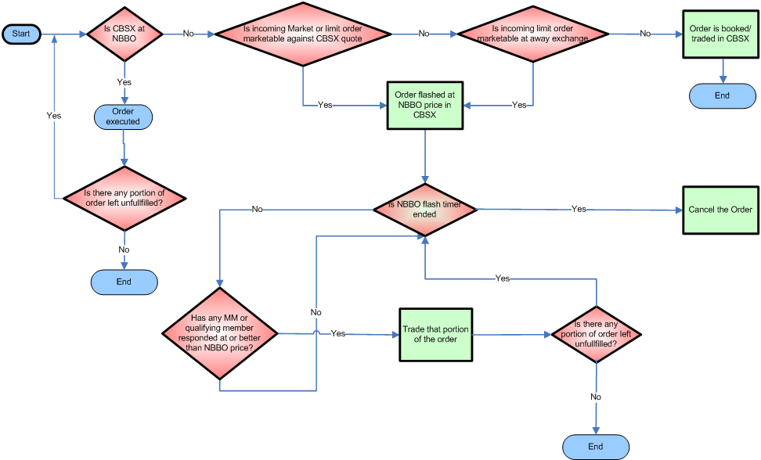

  - ‘DO NOT ROUTE’ contingency Enhancement
- CBOE direct will accept the order with ‘DO NOT ROUTE’ contingency.
- The order will trade immediately or book as long as they do not violate the NBBO, i.e., trade through or lock or cross.
- If a DO NOT ROUTE order cannot be booked or traded without violating the NBBO, it will be cancelled
- If it did not trade with the book or has remaining quantity the order will book.
- The ‘DO NOT ROUTE’ order will be available for any origin type, including ‘I’
- There will be no Flash and no autolink for such order.

‘DO NOT ROUTE’ Order – Business Flow

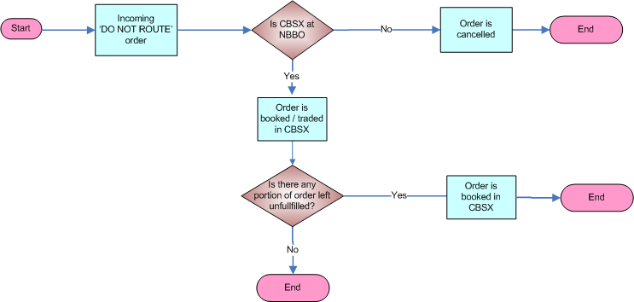

  - Multiple Router Enhancement
The multiple router enhancement (7.2 release) will allow multiple routing choices for linkage orders for equity. Additional routing firms viz. BRASS, OES etc. will be used other than REDI for linkage order processing. The firms will be selected for this purpose based on Linkage Router Assignment Routing Property’ / Post Routing Property / Backup Routing Property and Backup post routing property.
Following are the features of Multiple Router Enhancement:
- A new property will hold the preferred router by session, exchange, Firm and class.
- When a linkage order comes with a preferred router specified, OHS will match the router against the list of active routers, if the router is found but disabled, it will go through the regular process of selecting a router. If the router is not present it will go through the process of router selection but log an alarm that an invalid router came with the order.
- When a new linkage order comes in to send to linkage without a preferred router designated, OHS will round robin in the list of preferred routers according to the keys provided and will place it as an extra field in the order when sending to linkage.
- If all the routers in the list are disabled. OHS will switch to the backup preferred routers and round robin through that list as well.
- It should be possible to disable a router from a single list by removing it. Or disable it from al the lists by marking it disabled in the master list of routers.

Business Flow of Multiple Router

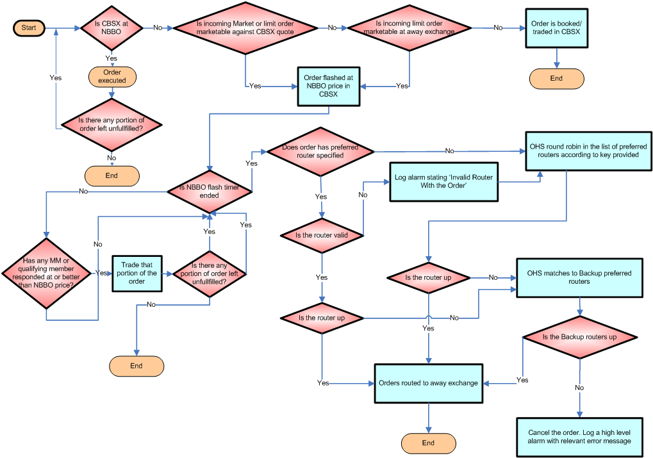

  - Drop Copies
Drop copies functionality of CBSX provide drop copies, which are order/quote fills, busted order/quote fills, to clearing firms / trading firms through FIX and CMi. This functionality is available on session / exchange basis, i.e. clearing firms that log in for CBSX fills will not get fills from CBOE or CFE. Firm display users for the clearing firms are defined to receive drop copies.

The clearing firm users (traders & small proprietary trading firms), trading firms users log into a single FIX engine or CAS and receive drop copies for all CBSX trades (including those from Quotes) for that clearing firm (executing or give – up firm in CBSX). The drop copies are sent to the clearing firm regardless of whether the order was entered through FIX or CMi. The clearing firms with multiple clearing numbers log in separately for each number. The trading firms receive a second copy of the fill report they are currently receiving, which is extra benefit to them to have a backup to their existing fill report in the event that they have system failures.

The drop copies are used by the clearing firms for the purpose of risk management by monitoring real time intra-day trading details for their clients. The drop copies can be generated for two business days (Current and previous business days).

Following reports are generated as drop copies:

- Order Fill Report - A report of a trade of an order
- Order Bust Report - A report of a bust of a trade of an order
- Order Bust Reinstate Report - A report of a reinstatement of a busted trade
- Quote Fill Report - A report of a quote trade
- Quote Bust Report - A report of a bust of a quote trade

Unacknowledged Drop Copies upon Firm Display User’s Login
Upon a firm display user logs into a single FIX engine or CAS, he will receive all his unacknowledged drop copies for his clearing firm and exchange.
(With POS Resend Flag=Y in Status Window)

Real Time Drop Copies during Firm Display User’s Login
When a firm displays user logs into a single FIX engine or CAS, he will receive real time drop copies for his clearing firm and exchange.
  - Clearing
The clearing of stock trades take place at DTCC (Depository Trust and Clearing Corporation) which provides clearing, settlement and information services for equities. CBSX sends the stock trade details four times every day at an interval of three hours (9:15 Am, 12:15 PM, 3:15 PM & 6:15 PM CST) to NSCC (National Securities Clearance Corporation), a DTCC subsidiary which is electronic arm of DTCC for trade clearance purpose. The trade reports contain data for following fields:
- Sender exchange
- Buy clearing broker
- Buy executing broker
- Buy entering broker
- Buy branch seq #
- Buy client order id1
- Buy client order id2
- Sell clearing broker
- Sell executing broker
- Sell entering broker
- Sell branch seq #
- Sell client order id1
- Sell client order id2
- Special trade indicator
- Settlement type
- Date type
- Trade_time
- Stock bond indicator
- Instrument type
- NSCC use
- Buy market control number
- Sell market control number
- Cusip
- When issued indicator
- Number of shares
- Price per share
- Currency indicator
- Odd lot indicator
CBSX sends the trade related data to DMZ of CBOE, from where the trade reports are sent to the DTCC. Further DTCC sends back the confirmation report with clearance detail within 2-3 hours from when the trade reports are received from CBSX. In case there is requirement to update already sent trade report, then new trade report is sent to DTCC with ‘R’ (replacement) remark. A separate trade report is also sent with ‘D’ (delete) remark for the trade which is required to be updated.
Process flow of clearing:
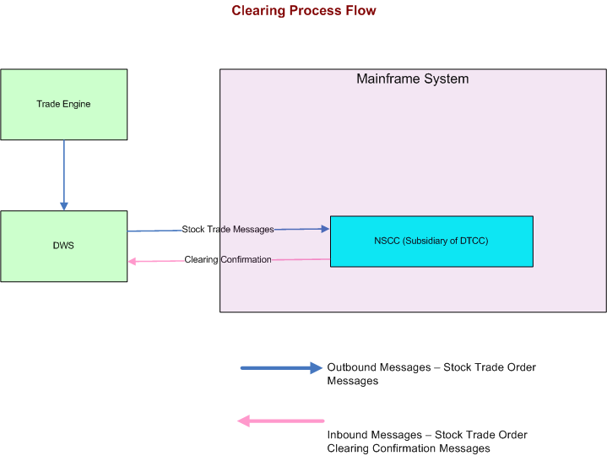

  - NBBO protection for ‘I’ order
Before implementation of 8.1 CBSX used to treat ‘I’ order similar to quotes and book (partially or fully) even if it locks or crosses an ‘away exchange’.
After 8.1 implementation, the ‘I’ orders are NBBO protected in CBSX. Now, the system will cancel the ‘I’ order instead to book, if it would cross or lock the away market. It has helped to prevent CBSX from locking or crossing away markets.

  - Bid Peg and Offer Peg Contingencies
New order contingency types, Bid Peg and Offer Peg is introduced in 8.1 that allows the user to send both sides of a cross as a protected order and have it print relative to the NBBO at the time. The contingency will allow the cross to be done either at the bid or the offer, or as an increment to the bid/offer.
- Order providers are able to specify on inbound paired orders whether the paired orders should cross at the NBBO bid price, the NBBO offer price, or ‘x’ better than the NBBO bid or offer price (where ‘x’ can be designated as a value in pennies including up to 4 decimal places to indicate sub-penny values). Means the sender can designate a specific crossing point.
- The contingency information sent on the paired order set have the following two characteristics:
- An indication that the paired order set should cross at the NBBO Bid or the NBBO Offer
(‘Bid peg’ vs. ‘Offer peg’).
- A numeric value stored in the contingency price field representing how many pennies
(including up to 4 decimal places to indicate sub-penny values) better than the NBBO Bid
or the NBBO Offer at which this paired order set should trade.
- If the specified increment should cause the price to go outside the NBBO (worse than the
NBBO), the system should only increment to the other side of the NBBO. For example:
  - If the NBBO is 0.82-0.83 and the sender specifies on the paired order set that the contingency is a ‘bid peg’ with a contingency price of 2, the expected crossing price would be 0.84, but because it violates the NBBO, the system should cross the orders at 0.83 (assuming that there is no book being traded through).
- Inbound order message format, fees, clearing etc. will be the same as for other cross orders.
- The paired orders will not interact with the book. There will no flash or auction.
- If the orders are unable to trade (either because there is a book present or for any other reasons), the sender will receive a message containing an existing reason code with detail why the trade was no successful.
- An existing billing code of ‘CC’ will be used on the trades for these orders.
- This contingency applies only to equity orders and the CBSX trading session.
- Note: The order price fields on these orders are set as ‘Market’.

  - ISB Contingency
ISB (Intermarket Sweep Book) contingency are allowed in CBSX. ISO (Intermarket Sweep Order) contingencies, which trade regardless of the NBBO and cancel any remaining volume after trading, are allowed into the CBSX session. This allows order providers to specify on inbound orders that, after trading; any remainder should be booked instead of cancelled. The remainder will be booked regardless of whether it crosses or locks an away market. So, the only difference between ISO and ISB order is that the ISB order will book any remainder instead of canceling the remainder (as for ISO).
Like ISO orders in CBSX, ISB orders should all be ‘day’ orders.
  - No Flash Contingency
In 8.1 Stock NBBO flash is turned off so instead of order auction, they will directly link away immediately. There is no auction facility for Round lot orders. The flash will work only the Odd Lot orders.

  - Contingency Cross Enhancement
As a part of this enhancement, sub-penny crossing restrictions will be added for 4 cross contingency types:
- Cross
- Tied Cross
- Bid Peg Cross
- Offer Peg Cross
The restrictions only apply when orders with these specified contingency types come in to the system with a price containing more than 2 decimal places. If orders with contingency type Cross within and Tied cross within come with a price greater than 2 decimal places, then they should be rejected with a response of ‘Invalid premium for contingency type’.
Orders that come into the system with any of the designated 4 contingencies should not be allowed to cross if all the following conditions are true.
- The cross price is one dollar or above
- The cross price is less than one penny from the bid or the offer.
- That bid or offer contains protected order at that price.
There are 2 exceptions to the rule above that may allow a sub penny cross. The exceptions are following
- If the crossing order meets the requirement of “Midpoint Rule”, they will be allowed to cross at a sub penny whether there are protected orders in the book or not.
  - Mid Point Rule – The NBBO spread is one penny wide and the crossing price of the order is exactly at the midpoint of the NBBO.
- If the crossing orders meet “Outsize Rule” conditions, they will be allowed to cross at a sub-penny price. Outsize rule conditions are the following
  - Number of shares >=CROSS MINIMUM ORDER_SIZE trading property
  - Notional Value >= CROSS_MINIMUM_DOLLAR_AMOUNT trading property
  - The size of the cross is bigger than the largest single protected order.

  - CBSX Market Order Handling

As a part of this enhancement acceptance of market orders are regulated based on the trading hours and contingency types. The acceptance of market orders is also regulated by few xml settings based on which the validation is performed or escaped. The basic business rule of this enhancement is “Market order without contingency MIDPOINT CROSS, BID PEG CROSS, & OFFER PEG CROSS is accepted if received within the regular trading hours”.

  - Tied Sweep and Cross

The Orders with contingency Tied Sweep and Cross is allowed to violate the NBBO, but must cross at or within the CBOE BBO. If there are protected orders in the way, then those orders must be swept first. The order may come into the system as paired or as separated orders. Individual ‘tied sweep and cross’ orders that come in will start a timer and wait until another order comes in to cross with it (must match up contingency, price, size, and opposite side). If the timer expires for an order, the order will be canceled. The orders with Tied Sweep and Cross must trade with CBOE market before trading with its corresponding TSC order. It is possible that the second order may only trade partially if the first order has to trade with the book first. This contingency type also needs to be governed by the sub-penny cross logic

- Application Architecture
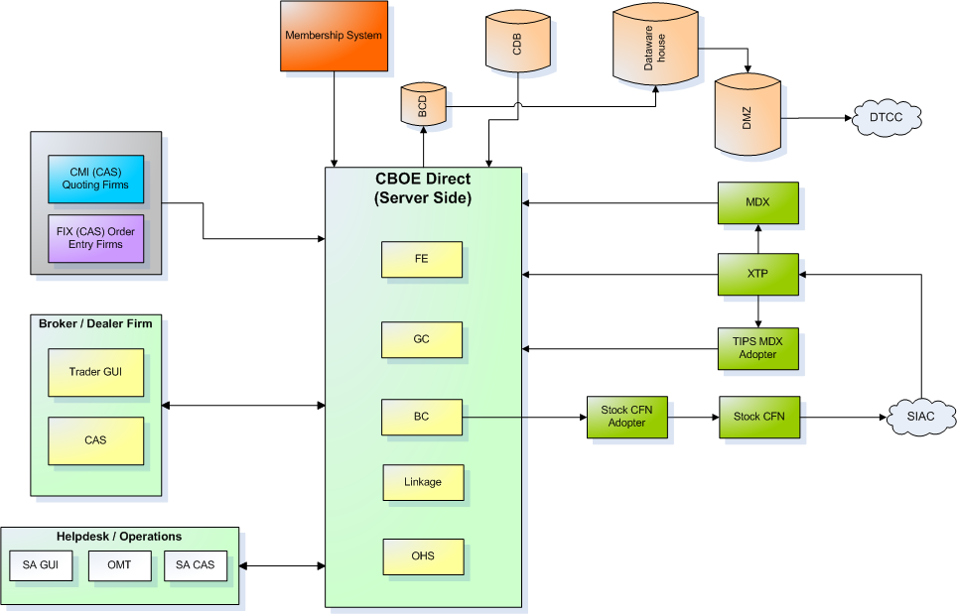
  - CBOE Eco Trading System
The applications in the CBOE ecosystem can divided into Trading systems and back-office. CBOE Direct comprises the Trade Engine which is the major part of the trading system. CDB and Data warehouse comprise the major back office systems.
SA GUI is the Help desk or operations GUI from where they control various parameters of the market like Trading properties, trading state whether open or closed etc. SA CAS is the application server for SA GUI.
Trader GUI is used to enter orders and quotes for stock. Trader GUI interacts with CBOE Direct through Front Ends with the Global Cluster (GC), Business Clusters (BC), Market Data Xpress (MDX) and linkage system which links CBOE to other exchanges for order routing in cases where the an order cannot be executed on CBOE. Business clusters are connected to databases called BCD, which in turn send data to Central Data-Warehouse.
Industry Products Database (IPD) has all the active products listed in it and this controls the contract introduction, expiration, and corporate action on various contracts trading at that point in time.
Membership system maintains the information about trading rights and privileges of various members.
XTP/TIPS are systems which process information received from external market data sources like MDX, industry bodies like SIAC in order calculate NBBO and also to facilitate availability of adequate trade related information.

  - Multi-Tier Architecture
The multi-tier architecture of CBOE is providing scalability to meet the high volume requirements inherent in CBOE’s markets.
Tier | Architecture Component | Responsibility
1 | CBOE Workstation, Member Application Program or third Party GUI | Presentation and interface to  Exchange services
2 | CBOE Client Application Server | Session management, authentication of user, caching of information to reduce bandwidth
3 | Fault tolerant Message Routing and Distribution | Message bundling, routing and distribution, reliable message delivery
4 | CBOEDirect Front End Processors | Application level routing between clients and exchange services
5 | CBOEDirect Services | Provides exchange services, such as trading, market data dissemination
- CBOE Workstation (Tier 1)
The CBOE Workstation is the name given to a set of interactive, graphical user interface (GUI) applications provided by CBOE that support member trading needs.
- Member or Third Party Programs (Tier 1)
Members can choose to build their own applications to operate using the CMi. CBOE will make every attempt to fully support the membership in creating their custom or third party applications.
- CBOE Application Server (CAS) (Tier 2)
The CBOE Application Server (CAS) is a platform independent, highly portable, robust application, written in Java that acts as a proxy and smart cache between the client application program and the exchange services. More precisely, the CAS sits between a client application, such as the CBOE Workstation or your own custom trading application, and the CBOEDirect Front End Processors. By using an Application Server approach, CBOE is able to minimize bandwidth consumption by minimizing the amount of duplicate information going to multiple clients. A theme throughout the CBOE Architecture is the use of caching to minimize bandwidth utilization.
Each CAS is connected to two CBOEDirect Front End Processors via the CBOE Network.
- CBOE Network and Messaging Infrastructure (Tier 3)
CBOE designed and implemented a fault-tolerant, high performance infrastructure using a combination of third party software, industry standards, and custom in-house development software.
- CBOEDirect Front End Processor (FEP) (Tier 4)
The CBOEDirect Front End Processor provides for application level routing between the CBOE Application Servers and the CBOE Exchange Services. The FEP also provides a primary and secondary access to CBOE Exchange Services.
- CBOE Exchange Services (Tier 5)
The services support electronic and open outcry markets. The Exchange Services include:
- Order Routing and Handling to both CBOEDirect and the Order Routing System (ORS) that supports open outcry markets.
- Market Data Publication
- CBOEDirect Electronic Trading Engines
- Trade reporting
    - CBOE direct logical view
CBOE Direct System logical architecture is explained in detail in “CBOEDirectLogicalView.doc” authored by CBOE Direct Server team. This section highlights and summarizes the important concepts mentioned in the same. For detailed description please refer to CBOEDirectLogicalView.doc
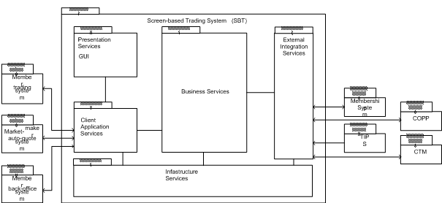
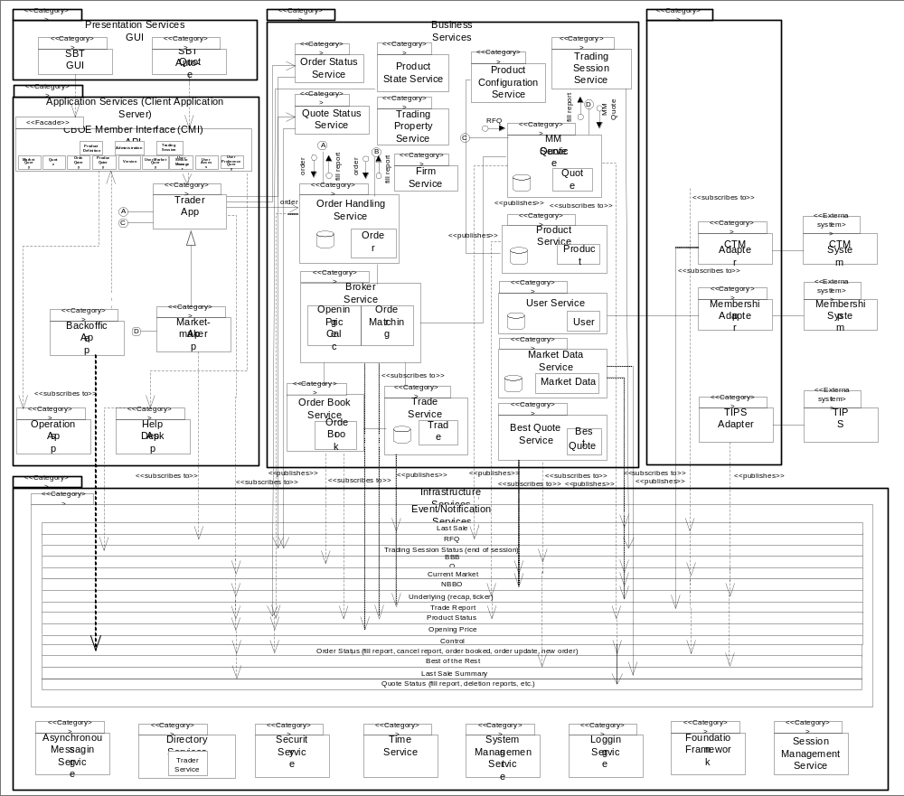
    - Detailed level logical view

    - Logical view Brief Description
- CBOE Direct system comprises of five logical service packages viz. Presentation Services, Application Services (Client Application Server), Business Services, External Integration Services, Infrastructure Services
- Presentation Service package consists of SBT GUI, Models, Internal Event Channels, Registered Call back Listeners, API Translator. Presentation Service provides an interface for human actors to communicate with CBOE Direct System.
- (Client) Application Service (CAS) package provides an application (and hence services) for each human actor, for example: Trader Application, Market Maker Application, Back Office Application, Operations Application, and Help Desk App. Most importantly CAS package consists of CBOE Market Interface (CMi) API. CMi API exposes the Trader, Market-Maker and BackOffice functionality through the API. CBOE provides set of CORBA IDL interfaces to expose CMi functionality. CBOE supports FIX based protocol in addition to IDL based interface.
- Business Service package provides core functionality of the trading platform. Important constituents are:
Order Handling Service has the responsibility for persisting the order, order validation, order forwarding, receiving order cancellation etc.
Broker service is the heart of CBOE Direct Trading platform. It is responsible for executing the orders, notifying the trade service, order handling service and market maker quote service.
Order Book Service has responsibility for opening price calculation, cancel/replace resting orders; publish the new NBBO, book depth and last sale.
Market Maker Quote Service is responsible for receiving RFQs from traders; submitting RFQs to market makers cancel/update the market maker quotes, quote history.
Other important sub packages include Trade Service, Product Query Service, User Service, Firm Service, and Exchange Service.
- External Integration package include adapter servers. These adapter servers provide translation services between CBOE messages and external services.
- Event Flows/Channels form the key interaction mechanism for various services and components to communicate. Event Channels work in publish subscribe mode. The diagram depicts the key event channels used by CBOE Direct system.
- Infrastructure services form the backbone on which application services and business services run. Asynchronous messaging, Trader (Directory) Service, Security service are few of the key infrastructure services.
  - CBOE direct system process view
This section describes the CBOE Direct system from the process point of view. This information is sourced from the CBOEDirect Flows.vsd (Author: Ravi Vazirani) and “CBOEDirectLogicalView.doc” (Author:CBOE Direct Server team).
    - Process View Brief Description
- Front-end server processes have routing proxies/concentrators for the various business services (e.g. Product Service, Order Handling Service, Order Book Service, Order Status Service, and Quote Status Service). Front-end server process does not maintain state.
- Business Cluster box has Equity Trade Server, External Trade Server, Hybrid Trade Server, Status Server, COPP Adapter, CTM Adapter and CFN Adapter server processes.
- Trade Servers (running on BC) internally have Order Handling Service, Best Quote Service, Market Maker Quote Service, Order Book Service, Product State Service, and Broker Service. There is very high degree of collaboration among these services
- BC box also runs adapter/external integration services e.g. COPP Adapter, CTM Adapter
- Global Server process running on Global Cluster (GC) box has Product Configuration Service, Product Service, User Service, Trading Session Service, and Firm Service.
- Infrastructure process runs on all the FE, BC, and GC boxes. Infrastructure process includes Trader (Object Directory), Security Service, Channel Admin, Distribution Nodes, Calendar Service, Time Service, Interface Repository, and Instrument Archiver service.
  - High Level Data Flow
    - Quote Flow Scenario
- Market Makers custom systems allow the market makers to provide auto-quotes. These systems send quotes in bulk so as to conserve the bandwidth. For Hybrid / Non Hybrid classes’ quotes may come through the CMi based clients.
- Quotes flow through CBOE network and reach the respective front-end server.
- Front End server routes these quotes to Market Maker Quote Service (MMQS) running on Distributed Trade Server processes. Distributed Trade Server process runs on BC (Business Cluster) box. Market Maker quote service puts the quote into the book. If a quote changes the top of the book, it is published on the Current Market channel. If quote status is changed, event is published on Quote Status channel.
- MD Broadcast Adapter service running on Global cluster server consumes the events on Current Market event channel and in turn those are published on Post Data Server.
- A typical inbound communication path for a quote can be summarized as p-to-p communication starting from Market maker Auto Quote System flowing through CAS, FE, MMQS on BC.
- The outbound flow for the quote is made possible using the publish-subscribe mechanism and event channels. The consumers interested in quotes for a particular class subscribe to the quote channels and apply the filter. The MDX servers notify the quote consumers for the new/changed quotes to the client systems.
- Infrastructure & Environment
  - ATG Environment Detail
There are multiple ATG environments namely - ATGTEST1, ATGTEST2, ATGTEST3, ATGTEST4, ATGTEST5 and ATGTEST6. Following are key layers of the environment:
GC: All components common to the CBOEDirect system run on these servers. Some of GC processes are responsible for Session Management, generation of unique database ids, maintaining all session configuration and all system wide trading properties, etc.
BC: The business server runs the trading engine and is responsible for accepting orders, quotes and executing trades. Note: In addition to Trading Classes being configured in sessions, the classes are also configured in routing groups. The routing group basically defines which Business cluster manages what set of products.
FE: The front end is used for routing messages (received by the CAS) to appropriate business server and to the global server.
CAS: The remote application that runs on the client side and communicates with the CBOEDirect trade engine processes. Note that the Front-end server on the global cluster is used by the SA CAS / SA GUI to connect and send messages to CBOEDirect.
MDGC: This is used to for receiving data from TIPS (underlying, BOTR), for receiving market data from MDX, sending book depth data to CFN for W_Stock and for sending broadcast messages to MDX.
  - Access to CBOE Environment
To access CBOE testing environment we need to access terminal servers using remote desktop application.
We have 4 terminal services available to access CBOE network,
170.137.248.106
170.137.248.19
170.137.248.20
170.137.248.21
  - Startup-Shutdown process information of CD in ATG environment
For detailed information on configuration of entire CBOEDirect system refer - CBOE_InfraSeven_InstallGuide.doc
All these process is done through control M process which starts at 5:00 PM daily which brings down all the ATG system including GC,BC, FE, CAS and infra processes on the respective boxes. This also does server cleans up for database and creation of new business day. After approximately one and half hrs, control M brings up all the ATG system.
Infa & server support takes care in the event of any issues regarding control M.
  - Extreme Ticker Plant (XTP)
    - Key Points
ATGXTP1B and ATGXTP1 are two boxes hosting XTP application in ATG environment.
ATGXTP1A is configured for live feeds from other exchanges
ATGXTP1B is configured for listening to simulator scripts.
ATGXTP1b box runs four/five instances of XTP applications meant for serving ATGTest1, ATGTest2 etc.
When we run the “scriptReplay - script name”, quotes are broadcast and each instance of XTP application running on ATGXTP1b listens to it. So that quote is updated for each environment.
XTP application further processes these quotes and then those are sent to PDS and CBOE.
Following is the XTP boxes configuration detail for different ATG / API environment.
XTP box details:
Environment | Box name | Login credentials
ATG1 | atgqaxtp1b | xtpenv1
ATG2 | atgqaxtp1b | xtpenv2
ATG3 | atgqaxtp1b | xtpenv3
ATG4 | atgqaxtp1b | xtpenv4
ATG5 | atgxtp2a | xtpenv5
ATG6 | atgxtp2a | xtpenv6
API1 | atgxtp2a | xtpenv8
API2 | atgxtp2a | xtpenv9
APICERT
TEST1 - TEST9 | devxtp5a | xtpenv1 - xtpenv9
TEST10 - TEST18 | devxtp7a | xtpenv10 - xtpenv18
- Testing Detail
  - Drop Copy User Setup
    - Manual Test Case Execution Procedure:
Option 1: ATG environment should have two CAS configured on it.
Option 2: We can use two different environments having separate CAS Boxes but pointing to the same FE. Build should be same on both of them.
    - Execution using Option1:
Status window can be used for verifying the messages for Firm Display users, Market makers and Firm users.
    - Execution using Option 2:
Two Environments required with same build and GUI should be available .If GUI not accessible or available ITG script can be used. (Atgtest6 and Atgfix6)
- User Setup: Functionality valid for W_STOCK.
W_STOCK: Exchange CBOEW
MM1: CBOEW / OPX: 338 (Active) (CBOEW)
MM2: CBOEW / MLP: 161 (Active) (CBOEW)
BD1: CBOE / PAX: 671 (Active) (CBOE)
    - Log Verification:
For the user for which GUI available status messages in the Status Window can be checked.
For the user for which ITG script is running API client file can be verified as below.

When the Firm Display user is not logged in and logged after the trade it will receive all the reports regarding his Firm .If you check in the API client file in the execution report there will be
PossResend=Y field for that particular order.

Search the order ID in the apiclient file using Branch Sequence number and verify other details also related to the order.

Firm display User apicleint Log:

Extract from apiclient log file:

ExecID=78142:922485116.78142:217016064.0
ExecBroker=CBOE:671
SecurityID=469763721
ClOrdID=DDD0126-20071214
TransactTime=20071214-20:11:20
ExecType=2

Firm Display User with PossResend flag Log:

Extract from apiclient log file
PossResend = Y
ClOrdID = DDD0127-20071214
TransactTime = 20071214-20:20:30

Trade Bust Report and Reinstatement of Busted Trade Quantity Message
There will be two reports one with text message as Trade bust and other message will be for reinstatement of busted trade qty as shown below:
Extract from apiclient log file

Message 1 for Trade Bust
ClOrdID = OOO0111-20071214
ExecTransType = 1
Text = Trade Bust Report
MaturityMonthYear = 200712
Open Close = C
Message 2 for Reinstatement of order:
ClOrdID = OOO0111-20071214
TransactTime = 20071214-20:51:41
ExecRestatementReason = 4
Text = Reinstatement of Busted Trade Quantity
MaturityMonthYear = 200712
  - Testing Details of NBBO Flash Enhancements Price Improvement
In the NBBO Flash Enhancements project the following will be implemented w.r.t. the Flash Responses
  - Flash Response trades with the Flash
  - Price improvement of the Flashed Order
  - Pricing to 4 decimal places of the Flash Response
  - Cancel remaining quantity of the Flash Response
  - Flash Response will not be Flashed
  - Flash Response will not be Auto Linked
    - Test Plan
The test plan constitutes of 209 test cases.
    - Test Setup Instructions:
Trading Property Setup: Some properties will be modified in the test plan in order to meet the requirements of the test cases

  - Allow Market Order = true

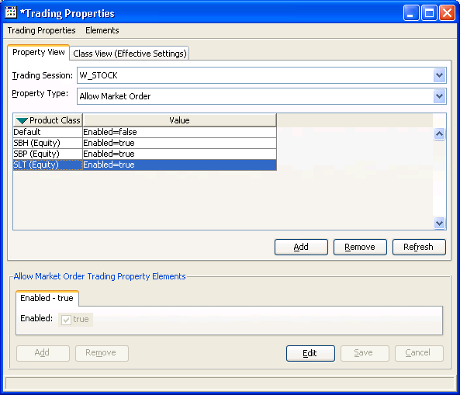

  - Auction Enabled
    - Stock NBBO Flash (6) = true
    - Stock Odd Lot (7) = true

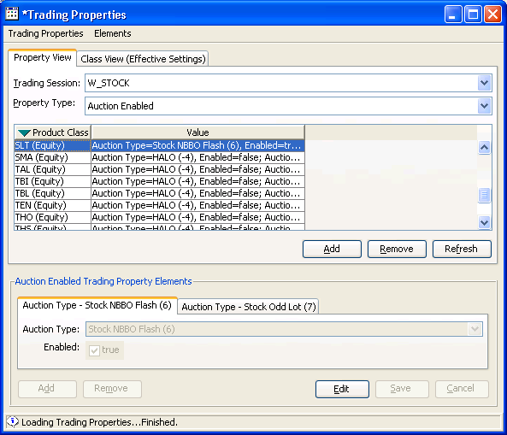
  - Auction Minimum Quoters
    - Stock NBBO Flash (6) = 0
    - Stock Odd Lot (7) = 0

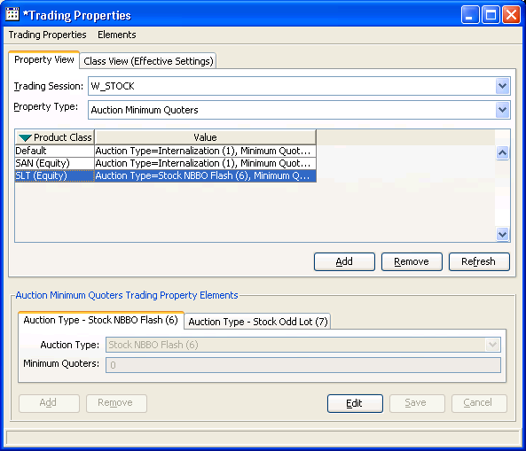

  - Auction Time To Live
    - Lower Limit = 60000, Upper Limit = 60000

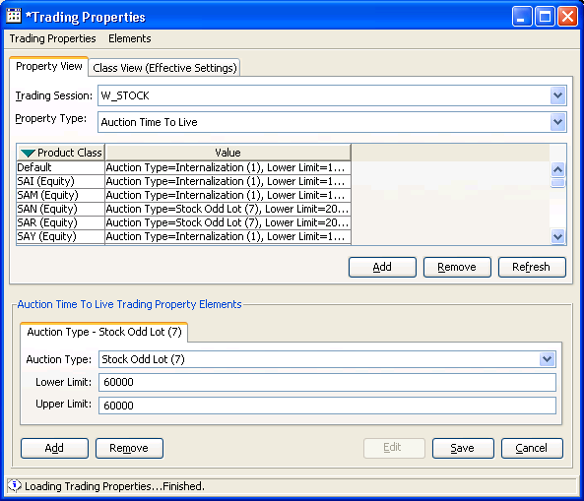
  - ETF Flag = true

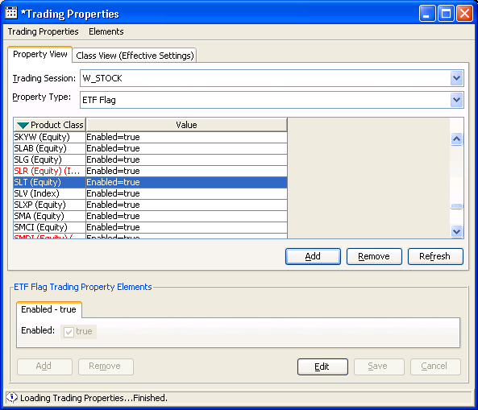

  - Enable Auto Link = true

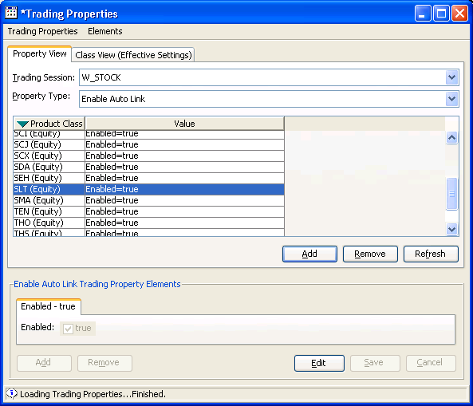

  - Exchange Prescribed Width
    - Minimum Bid Range = 0.0, Maximum Bid Range = 100.0, Maximum Allowable Spread = 100.0

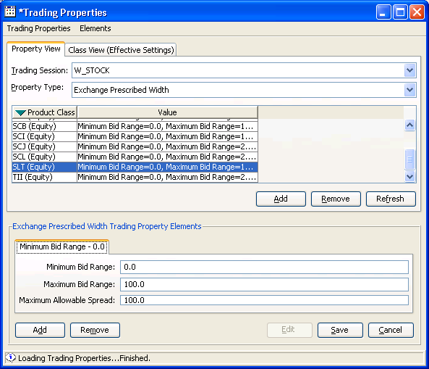

  - Lot Size = 100 (Make sure the default is 100)

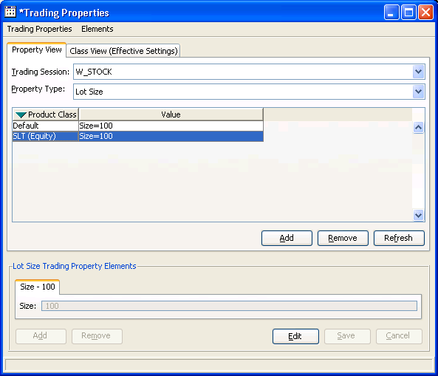

  - Opening EPW
    - Minimum Bid Range = 0.0, Maximum Bid Range = 100.0, Maximum Allowable Spread = 1.0

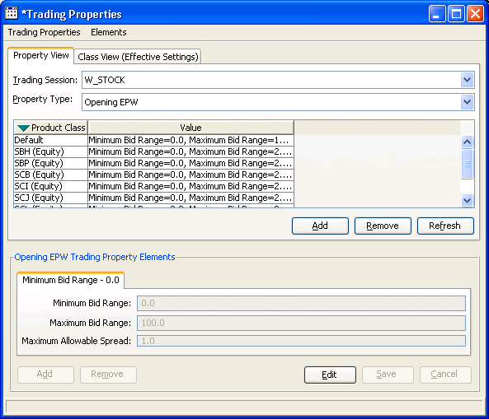

  - PA Order Time to Live = 60000

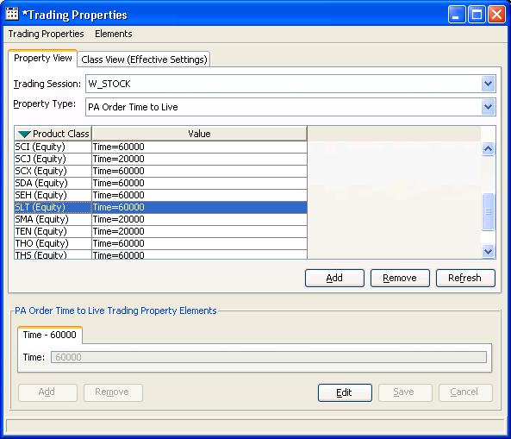

  - NBBO Cross Minimum Dollar Amount = 300

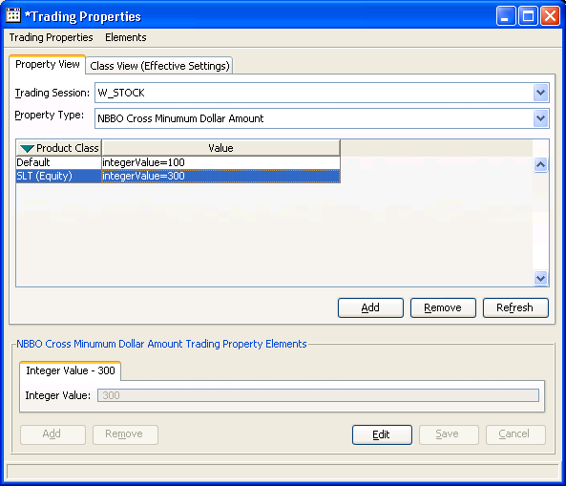

  - NBBO Cross Minimum order Size = 10

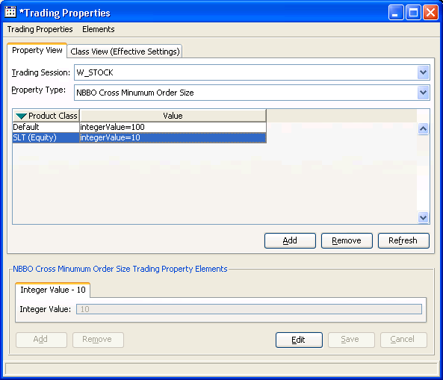

  - Cross Minimum Dollar Amount = 300

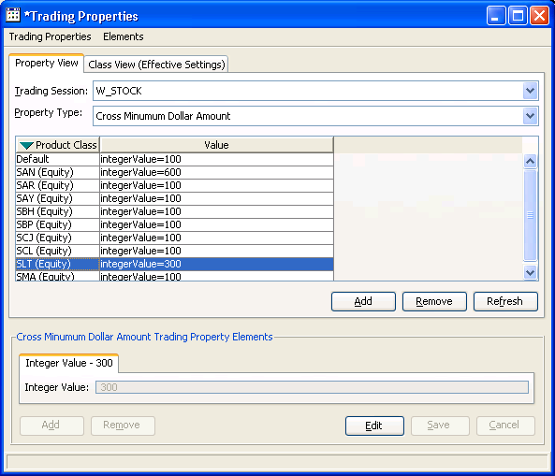

  - Cross Minimum order Size = 10
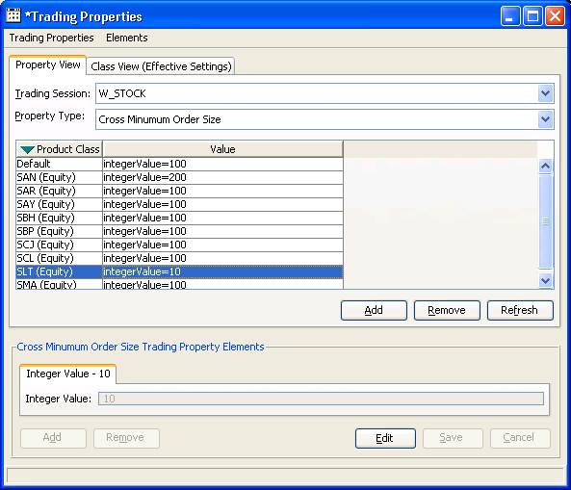
  - Testing Details of Help Desk Enhancement (HDE)
It is functionality in the SA GUI allowing a Help Desk user to ADD. REMOVE, FIND, DELETE, DISPLAY Groups also enable/disable users from a group, Clone a group, Cancel orders by a group.
    - Test Plan
The test plan constitutes of 31 test cases.

    - Test Setup Instructions:

  - Definition of User_Root: user root is a node, which is not displayed in the SAGUI; so all groups which user sees when he brings the user management window have a parent user root.
  - Definition of Top Level List: this is the tree of the user root or the groups displayed in the user management window when the user opens it.
  - For event channel testing at least two SAGUI s are required.
  - In Cancel order cases, orders have to be entered in W_Stock sessions: For some cases tester needs to enter orders in Hybrid session that are processed through external trade server
    - Test Cases
The Test cases for Help Desk Enhancement are available in the below path:
http://capitalmarkets.cognizant.com:8080/cboe/Repository1.asp

    - Key Requirements of application

  - Testing Environment should be up and working.
  - SA and Trader GUI of Testing environment should be and working.
    - Testing Details of Help Desk Enhancement (HDE) 2

It is functionality in the SA GUI allowing a Help Desk user to Display Product Hierarchy, Create New Product, Modify Product’s Post Station and Primary Exchange; Place a product in multiple stations, Delete Product, Auto Open Product.

    - Test Plan
The test plan constitutes of 17 test cases.

    - Test Setup Instructions:

  - 1 SA GUI is required
  - 1 Trader GUI is required
  - Operations mode must be enabled
  - IPD must be disabled

    - Test Cases
The Test cases for Help Desk Enhancement 2 are available in the below path:
http://capitalmarkets.cognizant.com:8080/cboe/Repository1.asp

    - Key Requirements of application

  - Testing Environment should be up and working.
  - SA and Trader GUI of Testing environment should be and working.

  - Testing Details of Help Desk Enhancement (HDE) 3

It is functionality in the SA GUI allowing a Help Desk user to specify certain parameters to cancel an individual user’s or a group’s orders.

These parameters are:
  - Cancel only Day orders on all BCs
  - Cancel only GTC orders on all BCs
  - Order cancel by BC
  - Order cancel by date
  - Order cancel by class
  - Order cancel by correspondent firm
  - Cancel orders based on the information in a spreadsheet

These parameters can be combined in any way. For Example: For User MM1, Cancel Day orders, entered Today, for Class AA.
There is also new functionality to allow the Search by Product State (Not Open).

    - Test Plan
The test plan constitutes of 45 test cases.

    - Test Setup Instructions:

Testing Resources Will Need:
  - 1 SAGUI
  - 3 Trader GUIs
  - Operations mode must be enabled

    - Test Cases
The Test cases for Help Desk Enhancement 3 are available in the below path:
http://capitalmarkets.cognizant.com:8080/cboe/Repository1.asp

    - Key Requirements of application

- Testing Environment should be up and working
- SA and Trader GUI of testing environment should be and working.

